CRIME DATA ANALYSIS IN THE CITY OF TORONTO

**A Project work for the course CSDA 1000 Introduction to Big Data – Winter 2020**

**Project members**

***Melkamu Gishu***

***Gordon Cameron***

***Parul Chaudhary***

***Paola Merrick***

***Submitted: February 26, 2020***

Table of Contents

**Abstract** **3**

**Introduction/Background** **4**

Problem Statement 4

**Competitive Analysis** **5**

Data Set Description 5

Variables to be Considered 5

Statistical Analysis 6

**Proposed Plan** **6**

**Cost/Benefit Analysis** **6**

**Reference Citation** **8**

# Abstract

Crime is a hot topic in any major city. It is the priority of politicians to reduce it, to improve safety within the city, which directly drives quality of life of the citizens, improves tourism and improves the economy [1]. Overall, the world is reported as a much safer place today than any other time in human history [2]. Crime in Toronto specifically has been reported on significantly in the past several years. There has been a rise in gun violence as reported by the media, accompanied by increased fear amongst the public.

This report intends to investigate trends in crime data within Toronto, to answer questions about whether the city is a safer place overall in 2019 compared to the beginning of data collection in 2014. Additionally, the report will intend to investigate trends over time, and within geographic neighbourhoods of the city, as well as using demographic data within these neighbourhoods. From this data, conclusions will be drawn, and suggestions made to attempt to focus on areas of improvement for law enforcement to increase resources, and reverse negative trends. Sensitivity to racial profiling and bias must be considered during this exercise.

Crime has a huge cost to the city of Toronto. Part of this report will aim to quantify it, and identify opportunity costs for the city, if it were able to improve on existing crime rates. There is a cost to enforcing the law, applying the justice system, and of course costs to the victims of crimes, which are sometimes very complex to measure [3]. Overall, bringing a reduction in the crime rate in Toronto would have considerable social and economic benefits on the city.

# Introduction/Background

Crime in Toronto has been relatively low in comparison to other major cities. In 2017, a ranking of 60 cities by The Economist ranked Toronto as the fourth safest major city in the world and the safest major city in North America[2, 3]. A CEOWORLD magazine ranked Toronto as the 95th safest cities in the world for 2018, running behind several other major cities like Tokyo, Osaka, Singapore, Hong Kong and Taipei but ahead of any other city in North America, other than New York City[4]. However, in 2018, Toronto had the highest homicide rate among major Canadian cities[5]. Toronto’s reached a record high homicide number count, with a rate of 3.11 per 100,000 people, higher than the 3.05 per 100,000 people for that of New York City[6]. The number of homicides that year broke the homicide record that was set 27 years prior[7].

With the increase in the number of crimes taking place in Toronto, it will be helpful to have a clear insight into the trends and correlates to better inform law enforcement agencies and other concerned parties to take an appropriate measure. With this in mind, we are going to explore an open data set of crime statistics from the Toronto Police Service dataset portal in order to investigate the following problems.

## Problem Statement

To analyze and explore the Toronto Crime data set to understand trends and patterns that will help predict any future occurrences, possibly the spatial distribution and patterns. Specifically the project will be required to answer the following questions:

* Exploring and describing major crime rates in the city of Toronto
* Determining correlates and predictors of crime?
* Describing the possible trends and identifying how crime rates change over time?
* Mapping hotspot areas for a major crime and forecasting future crime trends.

# Competitive Analysis

## Data Set Description

* A reported instance of major crime in Toronto will be pulled from the Toronto Police Service Open Data for the time of 2014 - 2019.
* Census tract profile from Stats Canada Census Profiles API
* We will also pull neighborhood profiles from the city of Toronto Open Data website in order to correlate crime with demographic data within each neighbourhood.

## Variables to be Considered

From Major Crime Indicators:

* Premise - House/Apartment/Commercial/Outside/Other
* Occurrence date - Day/Month/Year
* Occurrence hour
* Reported date
* Crime Category: Assault/Auto Theft/Break & Enter/Robbery/Theft over $5000
* Police Division
* Neighbourhood & ID
* Latitude/Longitude

From Census:

* Population, area, household & dwelling characteristics
* Age characteristics
* Marital Status
* Family Characteristics
* Language(s) spoken
* Income
* Employment & occupation type

## Statistical Analysis

Python version 3.x will be used with appropriate packages to perform the following statistical analysis.

* Descriptive analysis
* Regression analysis
* Time Series analysis
* Spatial analysis

# Proposed Plan

|  |  |  |
| --- | --- | --- |
| Activities | Timeframe | Notes |
| Concept note preparation by the team | Feb 13-14 |  |
| Data extraction and cleaning | Feb 15-21 |  |
| Analysis | Feb 27-29 |  |
| Result summary and writeup | Feb 25-27 |  |
| Preparing presentation and Submission | Feb 28 - March 5 |  |

# Cost/Benefit Analysis

The costs of major crime on society are considerable, and direct costs include victim costs, correctional costs, criminal justice system cost, and costs associated with undetected crimes. The Canadian government estimates the cost of crime at $5.86 million per person over 15 years [3], without even including the economic benefits that would be enjoyed if Canada’s crime rate were to drop significantly.

The cost per major crime type that is included in this analysis is represented in the figure below. This only considers the cost to the victim, so the overall cost would be considerably higher, showing the massive scale of benefit that can be gained if crime rates are reduced. Note the logarithmic scale in the figure below.

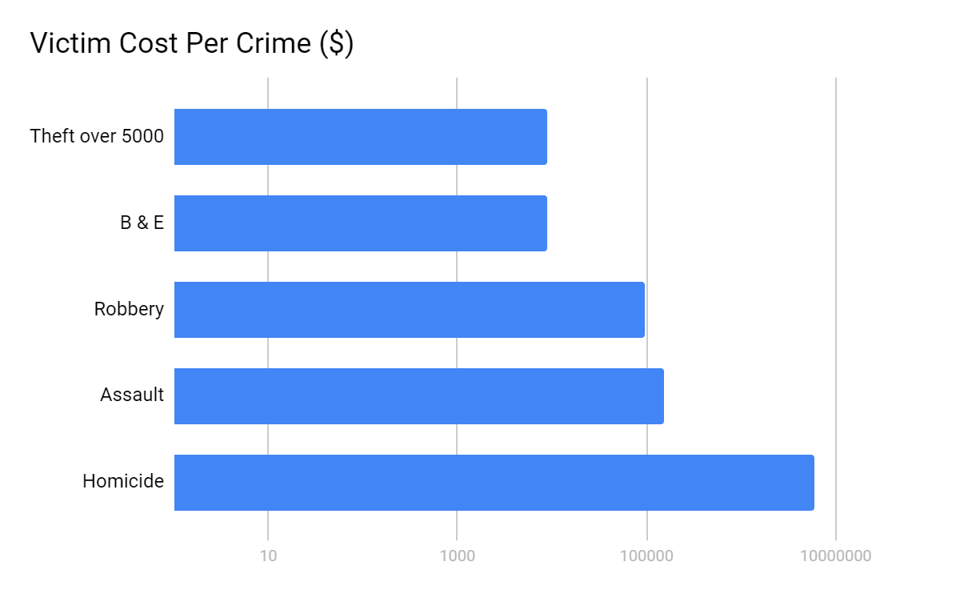

**Figure 1. Victim costs per crime type**

Costs of this project would include implementation of any suggestions that will be made based on the report’s conclusions. They may include additional police resources, community outreach programs, even additional spending into education and recreation programs can have a benefit that reduces crime rates. This type of spending will likely not outweigh the nearly $400k that the Canadian government estimates crime costs per citizen per year.

# Conclusion

Conclusions of this report will be drawn after performing the data analysis. However, the group expects to draw conclusions that the most violent crimes (murder, assault) are increasing over time, with nonviolent crime also increasing, or at least holding steady. The group expects to find areas with higher population density also have an increased crime rate, even when looking at a per capita basis. The group also expects areas with lower income to have higher crime rates, while those with higher incomes to have reduced rates in comparison.

A time series analysis of crimes may expect to show that more crimes happen overnight, when less observers are around, but the analysis of data will have to confirm.

Many additional insights are expected to be drawn from this analysis.

# 

# Reference Citation

1. Robert J. Shapiro, The Economic Benefits of Reducing Violent Crime. Accessed February 26,

2020. Available From: <https://www.americanprogress.org/issues/economy/reports/2012/06/19/11755/the-economic-benefits-of-reducing-violent-crime/>

2. T.J. Raphael, The world is actually safer than ever. And here's the data to prove that. Accessed February 26. Available from: <https://www.ijpr.org/post/world-actually-safer-ever-and-heres-data-prove#stream/0>

3. The Monetary Cost of Criminal Trajectories for an Ontario Sample Offenders. Accessed February 26th. Available from: [https://www.publicsafety.gc.ca/cnt/rsrcs/pblctns/mntry-cst-crmnl-trjctrs](https://www.publicsafety.gc.ca/cnt/rsrcs/pblctns/mntry-cst-crmnl-trjctrs/index-en.aspx#table_1)

4. <https://safecities.economist.com/safe-cities-index-2017/>. Available from: <https://safecities.economist.com/safe-cities-index-2017/>.

5. <https://web.archive.org/web/20170204085548/http://www.torontocrimemap.ca/>. Available from: <https://web.archive.org/web/20170204085548/http://www.torontocrimemap.ca/>.

6. <https://ceoworld.biz/2019/08/01/the-worlds-safest-cities-ranking-2019/>. Available from: <https://ceoworld.biz/2019/08/01/the-worlds-safest-cities-ranking-2019/>.

7. <https://www.huffingtonpost.ca/2018/11/20/toronto-homicide-rate-murder_a_23594924/>.

8. <https://www.ctvnews.ca/canada/stats-show-sharp-uptick-in-toronto-shootings-but-murder-rate-still-below-a-dozen-other-canadian-cities-1.4224142>. Available from: <https://www.ctvnews.ca/canada/stats-show-sharp-uptick-in-toronto-shootings-but-murder-rate-still-below-a-dozen-other-canadian-cities-1.4224142>.

9. <https://toronto.ctvnews.ca/toronto-s-most-deadly-year-a-look-at-the-96-homicide-victims-of-2018-1.4232568>. Available from: <https://toronto.ctvnews.ca/toronto-s-most-deadly-year-a-look-at-the-96-homicide-victims-of-2018-1.4232568>.